Project Design Phase-II
Data Flow Diagram & User Stories

Date | 29 October 2025
Team ID | NM2025TMID07034
Project Name | Optimizing User, Group, and Role Management with Access Control and Workflows
Maximum Marks | 4 Marks

Data Flow Diagrams (DFD)
- A Data Flow Diagram (DFD) visually represents how data moves through the User, Group, and Role Management System.
- It demonstrates how user requests are validated, approved through workflows, and executed securely using access control policies.
- This ensures data consistency, prevents unauthorized changes, and maintains complete audit tracking.

DFD Summary
The DFD emphasizes automation, validation, and accountability in user management.
It ensures every access update passes through a secure workflow and all activities are fully logged, reducing manual errors and ensuring compliance.

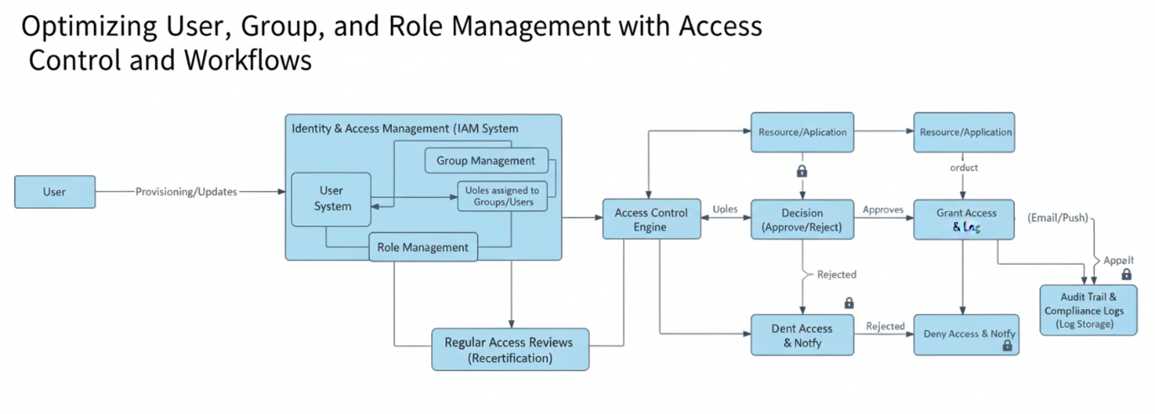

User Stories
User Stories capture the functional expectations of users and administrators.
They describe how each component of the system behaves within the context of workflow automation and access control enforcement.

User Type | Functional Requirement (Epic) | User Story Number | User Story / Task | Acceptance Criteria | Priority | Release
Administrator | User Management | USN-1 | As an admin, I want to create and modify users, assign roles, and manage group memberships through an approval-based workflow. | The system must validate inputs, ensure dependency checks, and trigger workflows for approvals before changes apply. | High | Sprint-1
System | Access Validation | USN-2 | As a system, I must validate user, role, and group dependencies before any modification or deletion. | The system should block updates that violate access control rules or dependency checks. | High | Sprint-1
Manager / Approver | Workflow Approval | USN-3 | As an approver, I want to review and approve user or role modification requests routed through workflow automation. | The system should send approval notifications, log actions, and update access after validation. | High | Sprint-2
Security Auditor | Audit and Logging | USN-4 | As an auditor, I want to review logs of all user and role activities for compliance purposes. | Every user, group, or role change must generate an audit record with time, user ID, and action details. | Medium | Sprint-3
User | Notification | USN-5 | As a user, I want to be notified when my access level or group membership changes. | The system must send automated notifications upon access modification. | Medium | Sprint-3

